Wong, Harvey
[Email address]

To participate as a vendor at this ICAO Event, please complete pages 1 & 2 and 4.

- Confirmation: Confirmation of the vendor agreement will be guaranteed by return of this duly completed and signed agreement along with payment of the total cost.

Applicant/Organization
Contact Person | Salutation Mr. Mrs. Ms. Dr.
First Name
Last Name
Title
Address
City |  | Province
Postal / Zip Code |  | Country
Tel No. |  | Fax No.
Email Address

- Exhibition Fees: The potential for visibility items offered by each package is detailed in the description boxes below. To view the exhibition floor plan and booth spaces, please see Appendix A on page 5. Please indicate below your booth number preferences and you will receive a confirmation of the booth number assigned to you via email from your event project manager. If you have not received one, please contact pruthapichairak@icao.int.

Remark:
1). Booth number selected will be confirmed in writing after the signed agreement has been received by ICAO.
2). Exhibitor may bring decoration pieces (e.g. pop-up banner, brochure, bar stools, laptops, marketing collaterals, etc.)
to display in their own area. Please note that ICAO will not be responsible for any set-up, transportation and customs
clearance of the exhibit’s material.

2.1 Exhibition Package

 | Exhibition Package Details | Booth number  (01–15) | Cost  USD
 | - One exhibition booth space 3m(W) x 2m(D) including:  Sample of a standard booth scheme  - Booth structure  - 1 Table and 2 Chairs  - Side and back wall  - Header Sign & Lighting  - Electrical outlet & wi-fi  - TV  - Brochure Stand  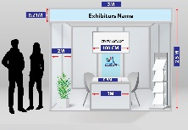  - Exhibitor’s company logo and web link on the event website.  - Exhibitor’s company logo inside the main meeting room  - Social media promotion through social media channels of ICAO-APAC  - Invitation to all hospitality events (Coffee breaks and lunch breaks and reception/dinners according to the programme);  - Two (2) complimentary event passes. |  | $6,500

Note: Booth No. 10 has already been reserved for the Host State of DGCA58, CAAB

2.2 Advertisement

 | Description | Selection / Timing | Cost/Day  USD
 | Video Advertisement*: Vendor’s advertising video to be played on screen in the conference room during break session of each day selected | 15 October 16 October  17 October 19 October | $2,500

Note: Please see privileges in APPENDIX B
*The programme is not available on 18 October 2023 – Cultural Tour Day

Total Cost

- Company Information and Corporate Logo

Your company logo, company web link will be included in the event website.
Please submit your required information and corporate logo by email to: pruthapichairak@icao.int

Company Information
- Company Name:
- Email Address:
- Website Address:

Corporate Logo:
The resolution must be a minimum of 300 dpi in one of the following formats: JPEG, AI, BMP, EPS.

4. Invoicing and Payment
Upon receipt of the duly completed vendor agreement form, ICAO will remit an invoice for the seminar(s) vendor fees; which will be sent by e-mail in a pdf format and the original will be mailed to the vendor.

Please select one of the following payments below. We prefer payment by credit card.

 | Bank Transfer |  | Cheque
 | VISA |  | Master Card
Requirements for payment: payments must be made prior to the event and will be due upon receipt of the invoice.
Methods of payment are: cheque, and bank transfer or major credit card listed above. If payment is not received
within fourteen (14) days, ICAO may not guarantee the customer’s first choice for the booth number.

5. Promotional Material
Vendors are prohibited from placing flyers, pamphlets, brochures and other promotional items (i.e. Pens, USB sticks, mugs, memo pads, etc.) on tables or stands other than their own. These tables or stands are reserved for ICAO. Vendors may use their assigned tables to display their marketing material.

Promotional materials must not promote military applications or make reference to the Republic of Taiwan.

6. Transportation and Customs clearance
ICAO will not be responsible for any transportation and customs clearance fee of the exhibition materials.

7. Registration for exhibitor / advertiser on The DGCA58 Website:
Once your signed Agreement is confirmed in writing by ICAO APAC office, the exhibitor/advertiser shall send ICAO APAC
the list of participants from each organization according to the privileges of each activity as stated in the Agreement. Each
exhibitor / advertiser who will participate in the conference is additionally required to register to the event on the DGCA58
Website as Exhibitor/Advertiser: http://www.dgca58.gov.bd/ after the confirmation with ICAO on exhibition/advertisement.

**Participants from each organization are required to register through the conference website, by person**

8. Cancellation Policy
This agreement signatory, in accordance with this provision, may withdraw the exhibition booking or sponsorship. Only a
written withdrawal notice sent by email to pruthapichairak@icao.int shall have an effect.

The withdrawal notice shall be deemed to have been given on the date such notice is received by ICAO at the
pruthapichairak@icao.int inbox. ICAO will acknowledge withdrawal notices received in a good order in writing. In the event of
withdrawal, refunds shall apply as follows:

If the cancellation request is: | Refund
More than 90 days before the start date of the event | Full refund
Between 60 to 90 days before the start date of the event | 50% refund
Less than 60 days before the start date of the event | No refund

9. Terms and Conditions

- By submitting this signed Exhibitor / Advertisement Agreement application form, the applicant whose information is completed at paragraph 1 (the “Applicant”) agrees with the International Civil Aviation Organization, headquartered at 999 Robert-Bourassa Boulevard, Montreal, Quebec, Canada, H3C 5H7 (“ICAO”), to abide by the Terms and Conditions set out herein. Applicants for exhibition space shall be referred to as “Exhibitors” and Advertisement Applicants shall be referred to as “Advertisers”.
- ICAO shall be under no obligation whatsoever in connection with any application, until written acknowledgement of ICAO’s acceptance of the application form. In particular, ICAO shall be under no obligation to accept an application form. For Exhibitors, the exhibition space is guaranteed only upon ICAO’s written acknowledgement and payment by the Exhibitor in accordance with paragraph 9 of this form.
- The person signing the Acceptance below represents and warrants that he or she is duly authorized to sign on behalf of the Applicant and that the Agreement shall be binding on the Applicant.
- All payments shall be made to ICAO in US Dollars only. If the invoice is not paid by the due date, ICAO may in its sole discretion, cancel the advertisement and/or exhibition rental space.
- All materials shipped to ICAO should be prepaid in full with the carrier. COD shipments shall not be acceptable to ICAO.
- The rights and obligations of the Applicant under this Agreement shall be non-assignable and non-transferable, except with the express written consent of ICAO.

- Exhibitors and Advertisers shall confine all business, demonstrations, exhibitions, canvassing, and distribution of printed matter or other items exclusively to the assigned booth space. No overflow into the aisles shall be permitted, due to fire and safety regulations. Promotional materials shall not promote military applications or name or make any reference to territories not formally recognised by the United Nations as sovereign states.
- ICAO makes no representations or warranties with respect to the demographic nature and/or number of exhibitors and/or attendees that will attend the event.
- ICAO accepts no responsibility or liability for any loss, damage or personal injury, arising in connection with this Agreement and the associated event(s). The Exhibitor should therefore make its own insurance arrangements in accordance with its requirements, risks and expectations. The Exhibitor shall indemnify, save and hold harmless ICAO and its employees or agents, from and against any claims, actions, losses, damages, expenses and costs whatsoever arising from the Exhibitor’s acts or omissions.
- Nothing in or relating to this Agreement shall be deemed a waiver, express or implied, of any immunity from suit or legal process or any privilege, exemption or other immunity enjoyed or which may be enjoyed by ICAO, its Officials and staff, under international or national laws.
11. The Applicant shall ensure compliance with the following:
a. Applicant’s products and services must not be contrary or be perceived to go against ICAO’s 5 strategic objectives or
the NCLB (No Country Left Behind) initiative.
b. The Applicant shall be in good financial standing with ICAO with no outstanding debts.
c. The Applicant shall not use the ICAO brand, logo or intellectual property, except with the express written approval of
ICAO.
d. Exhibiting or advertising the event will not pose any conflict of interest.
e. The Applicant’s participation may not be perceived as being negative to Member States or regions.
f. The Applicant should contribute, provide value and share knowledge with Member States and the civil aviation industry.

10. Acceptance
The undersigned hereby certifies that the terms and conditions set forth in this exhibition and advertisement agreement form to participate in the 58th Conference of Asia Pacific Director General of Civil Aviation (DGCA58), 15–19 October 2023, Dhaka, Bangladesh.

Signature: _______________________________________________ Date:

11. Return the Agreement
Save the duly completed and signed agreement and return it by e-mail in a pdf format to: pruthapichairak@icao.int.

Appendix A – Exhibition Floor Plan
Layout of the Exhibition Booth: Booth No. 01 – 10 (Indoor) and No.11 – 15 (Outdoor)
Please note that the number and location of booth arrangement shall be adjusted as deemed appropriate.
The updated total number of booths shall be viewed in the DGCA58 website: http://www.dgca58.gov.bd/
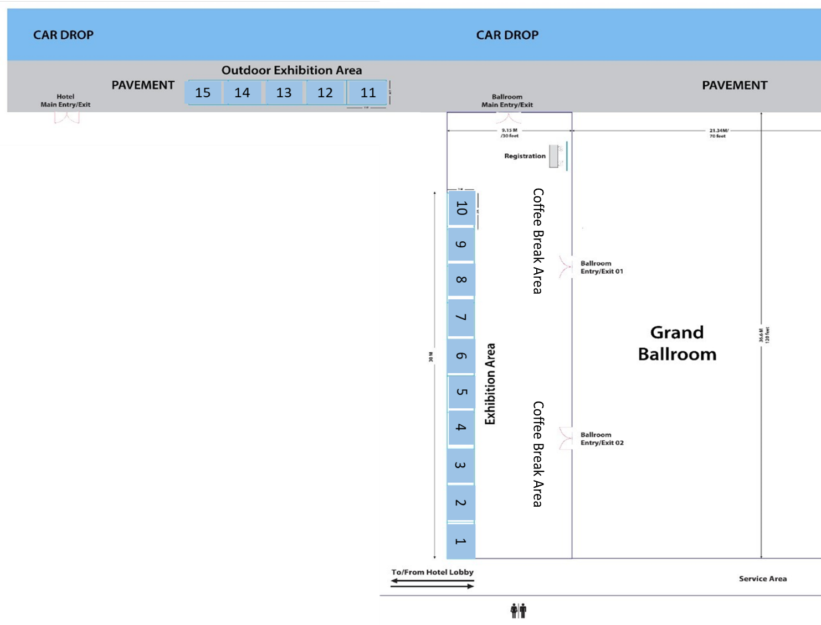 Booth Dimension:
Remark: Booth No.10 is reserved for the Host State
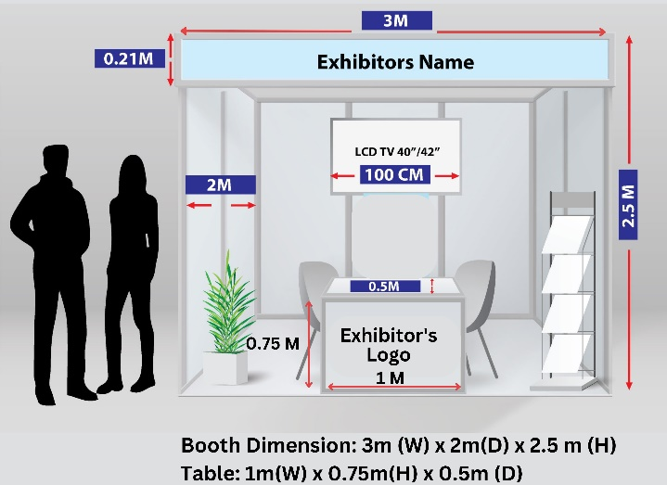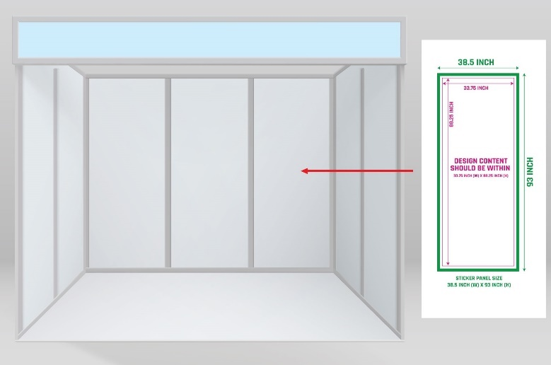

Appendix B:
Section A: Advertisement privileges

Advertisement Privileges | Video Advertisement
Vendor’s advertising video display during the Break Session or after each session according to the selected package. | ✓
Recognition by the event moderator or MC during the event. | ✓
Visibility in the event website displaying the advertiser’s logo | ✓
Advertiser’s logo on social media channel of ICAO-APAC | ✓
The number of organization representative to attend the DGCA58 conference as observer | 1

Section B: Additional Material Requirements and Specifications

  - Video Advertising
*For Video Advertisement Sponsors

- Size (pixels): 1920 x 1080 (optimal option) or 1280 x 720
- Format: .mp4
- Language: English

